Indian Puppetry
Wednesday, April 4, 2018
12:08 AM

Origins in India
  - Excavation sites at Harappa and Mohenjodaro shown puppets with sockets attached to them
  - Oldest written reference to puppetry found in Tamil classic Silappadikaram

Types
  - String Puppets/Marionettes

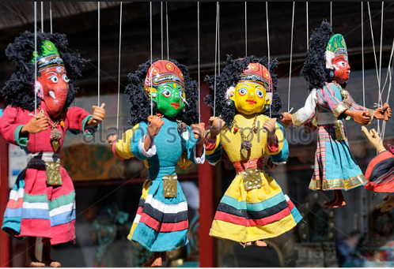

  - Shadow Puppets

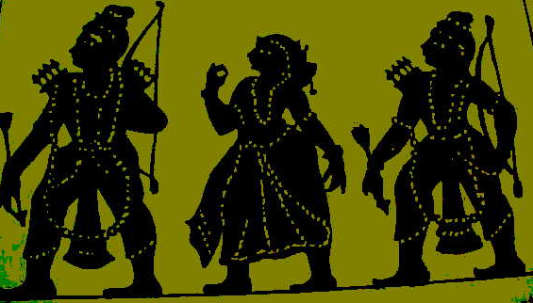

  - Glove puppets/sleeve/hand/palm puppets

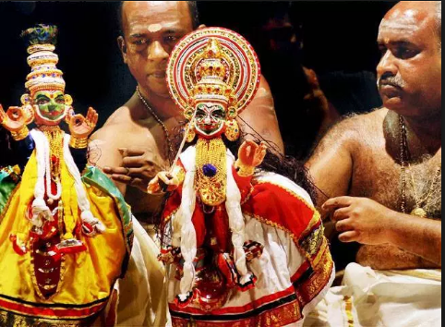

  - Rod puppets
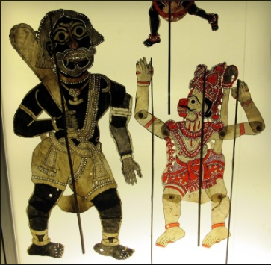

  - Overview
String puppet
Kathputli | Rajasthan | Wood doll, Absence of legs is unique feature
Kundhei | Odisha | More joints and strings attached to triangular property
Gombeyatta | Karnataka | More than one puppeteer
Bommalattam | TN | Largest and heaviest, String attached to iron ring which is worn by puppeteer on his head
Shadow puppet
Tholu Bommalata | AP
Ravanchhaya | Odisha | Deer skin and bold, dramatic postures  (NOTE: Ravan Chaya caves also present in Odisha)
Togalu Gombeyatta | Karnataka | Variation of puppet size based on social status
Glove puppet
Pavakoothu | Kerala | Heavy influence of Kathakali
Rod puppets
Yampuri | Bihar
Putul Nachh | Bengal-Odisha-Assam

